**CPS 571 HW2**

Shengxin Qian

1. **ROC and AUC**

|  |  |  |
| --- | --- | --- |
| y | Linear decision | Nonlinear decision |
| 0 | -1.7 | 0.1545 |
| 1 | 0.7 | 0.6682 |
| 1 | 3.55 | 0.9721 |
| 1 | 1.1 | 0.7503 |
| 1 | 0.65 | 0.6570 |
| 0 | -1.65 | 0.1611 |
| 0 | -1.55 | 0.1751 |
| 0 | 0.55 | 0.6341 |
| 1 | 3.65 | 0.9747 |
| 0 | -1.85 | 0.1359 |

**Chart. 1 decision statistics of two classifiers**

(a). The required threshold range is [0.55, 0.65], the corresponding confusion matrix is:

|  |  |  |
| --- | --- | --- |
|  | Predicted yes | Predicted no |
| Actual yes | 5 | 0 |
| Actual no | 0 | 5 |

**Chart. 2 confusion matrix of classifier g(x)**

(b). The required threshold range is [0.6341, 0.6570], we can choose any threshold in this range with no misclassification error. The corresponding information is:

**Confusion matrix:**

|  |  |  |
| --- | --- | --- |
|  | Predicted yes | Predicted no |
| Actual yes | 5 | 0 |
| Actual no | 0 | 5 |

**Chart. 3 confusion matrix of classifier f(x)**

**Precision**: 1

**Recall**: 1

**F1 score**: 1

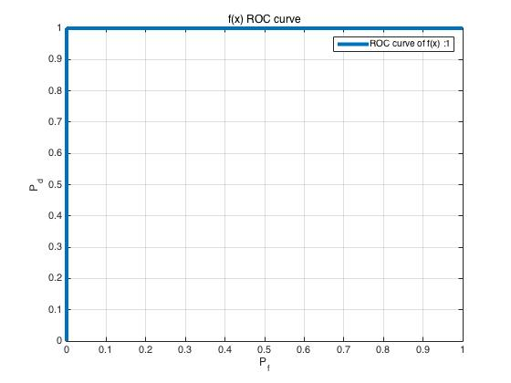(c). As we can see in Figure 1, the AUC = 1

**Figure 1. ROC curve of classifier f(x)**

(d). There would no change between the ROC curve of f(x) and h(f(x)). Because the order of each confidence will not change. You can always find a threshold to obtain the same separation.

1. **Decision Tree**

(a). **Initial Gini index**:

**X1 Gini index**:

**X2 Gini index**:

**X3 Gini index**:

**X1 Gini index reduction:**

**X2 Gini index reduction:**

**X3 Gini index reduction: $\frac{1}{2}- \frac{5}{12}= \frac{1}{12}$**

Obviously, we should choose **X1** feature.

(b). Obviously, we should choose **X1** feature.

**X1 Information Gain**:

**X2 Information Gain**:

**X3 Information Gain**:

* 1. 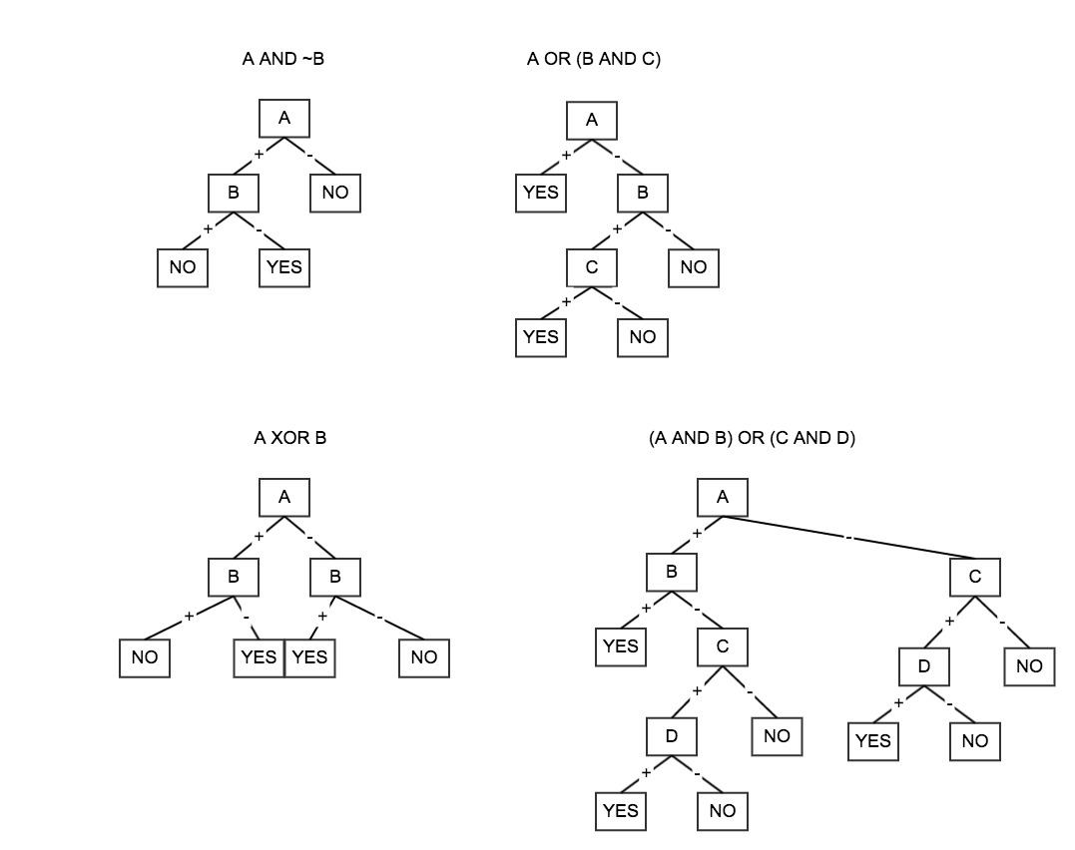**Decision Trees**

**Figure 2. Logical functions Decision Trees**

* 1. **Decision Trees and Random Forests**

(b). Given distribution:

|  |  |  |  |  |
| --- | --- | --- | --- | --- |
| X | [0, 0.45] | [0.45, 0.5] | [0.5, 0.55] | [0.55, 1] |
| Label | P | N | P | N |
| Pr of range | 0.495 | 0.005 | 0.005 | 0.495 |
| Pdf | Uniform | Uniform | Uniform | Uniform |

As we see in the chart, this distribution has four ranges, in each range is uniformly distributed. The probability of each range is significantly different.

Because random forests draw a bootstrap sample and use major vote of decision trees in the forest, random forest tend to use 0.5 to do the separation and ignore the outliers. Label the test data with P, when <= 0.5 and label the test data with N, when > 0.5. However, when we use decision tree, as long as n is big enough, we will have a separation between frequent ranges and rare ranges. When n is low, the random forest may not have difference with decision tree because the number in rare ranges will not appear.

**Code:**

**main.m**

clc

clear

M = csvread('dataset.csv',1,0);

label = M(:, 4);

train = M(:, 1:3);

theta = [0.05 ; -3 ; 2.5];

cons = 0.3;

linear_decision = linear_c(theta, train', cons);

[P_linear, R_linear, F1_linear, Confusion_linear, threshold_linear, threshold_linear_range] = find_t(linear_decision, label);

nonlinear_decision = nonlinear_c(theta, train', cons);

[P_nonlinear, R_nonlinear, F1_nonlinear, Confusion_nonlinear, threshold_nonlinear, threshold_nonlinear_range] = find_t(nonlinear_decision, label);

AUC_nonlinear = plotROC(nonlinear_decision(label == 0), nonlinear_decision(label == 1));

title('f(x) ROC curve');

legend(['ROC curve of f(x) :',num2str(AUC_nonlinear)]);

grid on;

**linear_c.m**

function y = linear_c(theta, x, cons)

y = theta' * x + cons;

y = y';

end

**nonlinear_c.m**

function y = nonlinear_c(theta, x, cons)

y = 1 ./ (exp(-1 * (theta' * x + cons)) + 1);

y = y';

end

**find_t.m**

function [P, R, F1, Confusion, threshold, threshold_range] = find_t(data, label)

minError = length(data);

for i = linspace(min(data), max(data), 2000)

pe = (length(data(label == 0 & data >= i)) + length(data(label == 1 & data < i)));

if minError > pe

threshold = i;

minError = pe;

end

end

P = length(data(label == 1 & data >= threshold))/(length(data(label == 1 & data >= threshold))+length(data(label == 0 & data >= threshold)));

R = length(data(label == 1 & data >= threshold))/length(data(label == 1));

F1 = 2 * P * R / (P + R);

Confusion(1,1) = length(data(label == 1 & data >= threshold));

Confusion(1,2) = length(data(label == 1 & data < threshold));

Confusion(2,1) = length(data(label == 0 & data >= threshold));

Confusion(2,2) = length(data(label == 0 & data < threshold));

t = data(data <= threshold);

threshold_range(1) = max(t);

t = data(data >= threshold);

threshold_range(2) = min(t);

end

**plotROC.m**

function AUC=plotROC(H0_1,H1_1)

index=1;

min0=min(H0_1);

min1=min(H1_1);

max0=max(H0_1);

max1=max(H1_1);

mean0=mean(H0_1);

mean1=mean(H1_1);

if(min0>=0)

min0=min0*0.8;

else

min0=min0*1.2;

end

if(min1>=0)

min1=min1*0.8;

else

min1=min1*1.2;

end

if(max0>=0)

max0=max0*1.2;

else

max0=max0*0.8;

end

if(max1>=0)

max1=max1*1.2;

else

max1=max1*0.8;

end

for beta=min(min0,min1):0.001:max(max0,max1)

if(mean1>=mean0)

Pd_1(index)=sum(H1_1>=beta)/length(H1_1);

Pf_1(index)=sum(H0_1>=beta)/length(H0_1);

else

Pd_1(index)=sum(H1_1<=beta)/length(H1_1);

Pf_1(index)=sum(H0_1<=beta)/length(H0_1);

end

index=index+1;

end

if(mean1>=mean0)

AUC=-trapz(Pf_1,Pd_1);

else

AUC=trapz(Pf_1,Pd_1);

end

figure;

p=plot(Pf_1',Pd_1','LineWidth',4);

xlabel('P_f');

ylabel('P_d');